Data persistence in the Parcel Mapping [Excel]

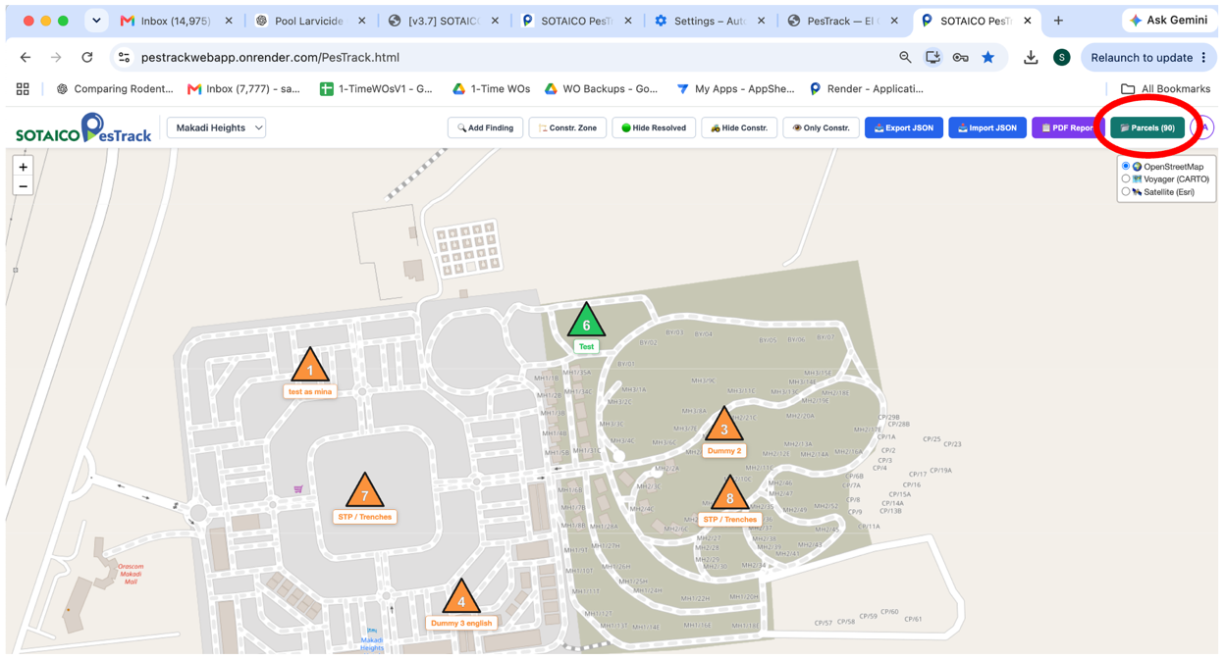

I initially loaded an excel sheet for the parcels, which included both Gouna and Makadi parcel mapping coordinates (78 corrdinates)

I subsequently re-loaded the excel mapping for only Makadi coordinates – just 2 parcels on the excel sheet (see attached). I receive this message and the dashboard still shows 90 parcels:
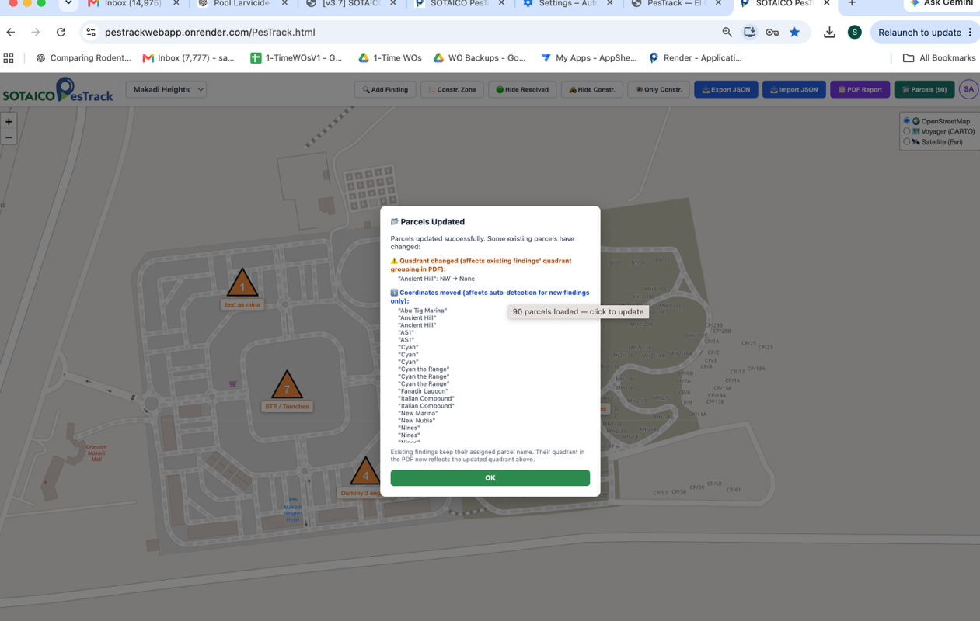

Note that findings on the Makadi dashboard are correctly assigned to the 2 parcels that are in the Makadi excel Parcel sheet.

